**9.5 or 23.75/25**

Assignment 2

Sandra Rós

Question 1

1. Item 5 is the easiest and item 10 is the hardest 2
2. -1.63 +/- 1.96 * 0.13. We can say with 95% confidence that true item difficulty (-.5) for the easiest item lays between -1.88 and -1.38. 1.5
3. Item 5 = black line 1

Item 10 = red line

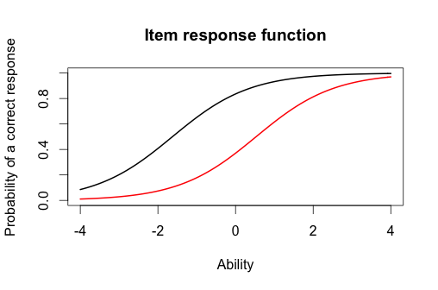

1. For the easiest item we could expect the probability of a correct response would be around 0.8 and the probability for getting the hardest item correct would be around 0.25. 2
2. The person who did the best on the test scored 3.99 and the person who did the worst on the test scored -3.99 2
3. We can say with 95% confidence that the true ability (-.5) of the person who did the best on the test lies between -0.329 and 8.309. ( 3.99 +/- 1.96*2.204) 1.5

> # Estimated Parameters

> est_params <- rasch_model$est

> colnames(est_params) <- c("Discrimination", "Difficulty", "Guessing")

> rownames(est_params) <- paste("Item", 1:18)

> est_params

Discrimination Difficulty Guessing

Item 1 1 -1.40938612 0

Item 2 1 -0.35055656 0

Item 3 1 -0.90318970 0

Item 4 1 -0.97412011 0

Item 5 1 -1.62671110 0

Item 6 1 0.02533657 0

Item 7 1 -0.41418545 0

Item 8 1 -0.87993298 0

Item 9 1 -0.91498121 0

Item 10 1 0.52959427 0

Item 11 1 -1.17125435 0

Item 12 1 -0.04749604 0

Item 13 1 0.15008663 0

Item 14 1 -0.74253017 0

Item 15 1 -0.74245332 0

Item 16 1 0.36963876 0

Item 17 1 -0.84513136 0

Item 18 1 -1.45145349 0

# Standard Errors

> est_se <- rasch_model$se

> colnames(est_se) <- c("Discrimination SE", "Difficulty SE", "Guessing SE")

> rownames(est_se) <- paste("Item", 1:18)

> est_se

Discrimination SE Difficulty SE Guessing SE

Item 1 NA 0.1267448 0

Item 2 NA 0.1128011 0

Item 3 NA 0.1178581 0

Item 4 NA 0.1188426 0

Item 5 NA 0.1320051 0

Item 6 NA 0.1118476 0

Item 7 NA 0.1131572 0

Item 8 NA 0.1175527 0

Item 9 NA 0.1180162 0

Item 10 NA 0.1136598 0

Item 11 NA 0.1220123 0

Item 12 NA 0.1118797 0

Item 13 NA 0.1119630 0

Item 14 NA 0.1159197 0

Item 15 NA 0.1159189 0

Item 16 NA 0.1126941 0

Item 17 NA 0.1171115 0

Item 18 NA 0.1276902 0

plot(irf(est_params[c(5,10),]), co = NA)

> est_abl[393,]

est sem n

393 -3.999947 1.225286 18

> est_abl[49,]

est sem n

49 3.999921 2.204373 18

> plot(iif(est_params[c(1,6,14),]), co = NA)

> plot(tif(est_params))

Question 2

1. Items 1, 6 and 14 1
2. 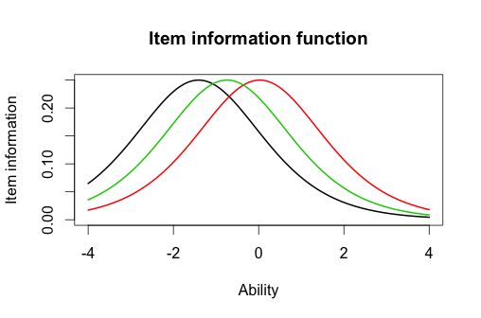Plot for these three item information function 1
3. The shape is the same but they do not have maximum information (-.25) at the same location. 1.75
4. 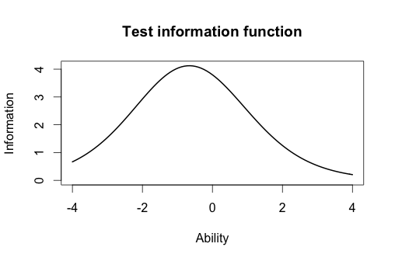Plot for test information function 1
5. The majority of the information for the test is located around -0.8

1

Question 3

1. Item 8 had the highest discrimination and item 12 had the lowest discrimination. 2
2. In the Rasch model, item 5 was the easiest and item 10 was the hardest. In the 2-PL model item 1 was the easiest and item 10 was the hardest. Therefore the hardest item is the same in Rasch and the 2-PL model but not the easiest item. 1
3. The correlation between the ability estimates on the Rasch model and the 2-PL is 0.971. I would draw the same conclusion from both models when estimated about persons ability, as the correlation is very high. 2
4. Plot of the item information function for Items 1,6 and 14. 1

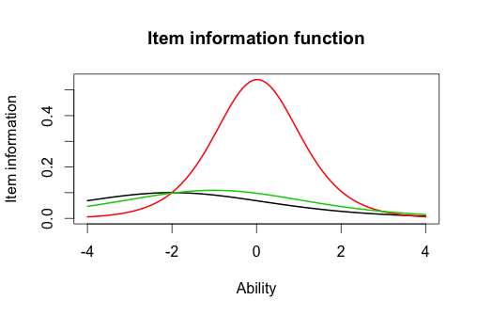

1. The difference between these items is the item discrimination, as item 6 has the highest discrimination and therefore has the most information compared to item 1 and 14. The Rasch model provides information about item 1 and 14, but the 2-PL model has almost no information about these two items.

1 point

# Estimated Parameters

> twopl_params <- twopl_model$est

> colnames(twopl_params) <- c("Discrimination", "Difficulty", "Guessing")

> rownames(twopl_params) <- paste("Item", 1:18)

> twopl_params

Discrimination Difficulty Guessing

Item 1 0.6326689 -2.00058101 0

Item 2 1.5469622 -0.26815483 0

Item 3 1.2534918 -0.77297206 0

Item 4 0.9842598 -0.97706755 0

Item 5 1.6407242 -1.19389580 0

Item 6 1.4702029 0.01833431 0

Item 7 0.5632837 -0.65124651 0

Item 8 2.2881772 -0.56753253 0

Item 9 1.8004066 -0.64761748 0

Item 10 1.1142107 0.48542889 0

Item 11 1.0344119 -1.13363005 0

Item 12 0.3329130 -0.12951933 0

Item 13 0.3369968 0.36344671 0

Item 14 0.6608229 -1.01479867 0

Item 15 1.5980393 -0.55640285 0

Item 16 1.0362116 0.35459121 0

Item 17 1.8591845 -0.59017915 0

Item 18 1.2808752 -1.22177042 0

twopl_abl <- as.data.frame(mlebme(Scored, ip = twopl_params))

> # Correlation between the ability estimates

> cor(twopl_abl$est,est_abl$est)

[1] 0.9709497

> plot(iif(twopl_params[c(1,6,14),]), co = NA)